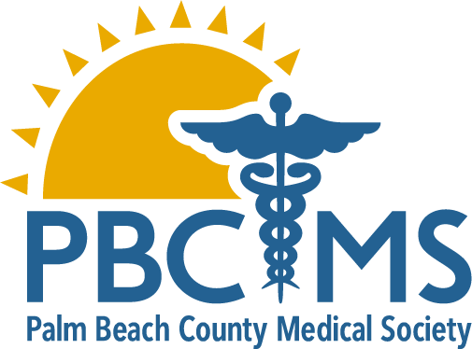
Call for
applications

Supported by a Grant from
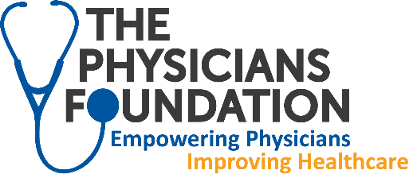
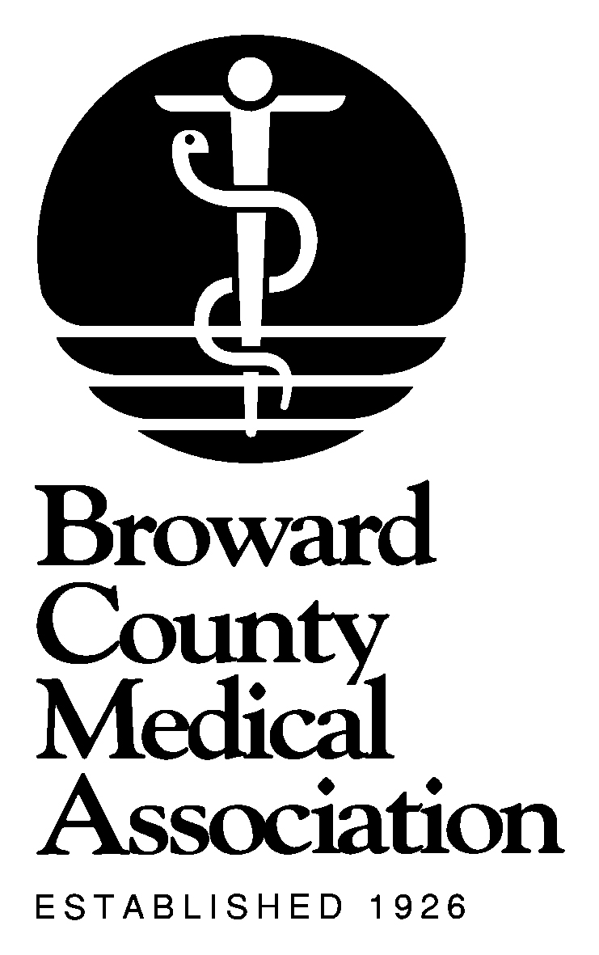
Physician Leadership academy (PLA) of South Florida 2018- 2019
Questions or to be sent a fillable nomination application form call 561-433-3940 #122
Submission Deadline: September 15th

Physician Leadership Academy (PLA) of South Florida
The PLA experience will help physicians who want to build and/or improve their leadership skills. Interactive classes will enable physicians to enhance organizational management skills, develop continuing relationships with colleagues and strengthen their leadership roles in the diverse communities of South Florida. The program will include seven sessions. Effective physician leadership will continue to be critical for patients and the medical profession as health care systems continue to evolve. With attendance at all sessions, the PLA will offer a select group of South Florida physicians with:
-at least 40 AMA Category 1 CME credits (with full attendance),
-a diverse array of leadership skills training,
-tools to make significant impacts in roles they play or plan to play,
-vital information about health care issues facing Floridians, and
-access to a growing professional network.

This program held under the auspices of the Palm Beach County Medical Society/Services in partnership
with Broward County Medical Association and Dade County Medical Association, is funded through a grant from The Physicians Foundation, is endorsed by the Florida Medical Association and is free to all participants.

All PLA class members, working with fellow members from their respective counties, will complete a Leadership Project. The Leadership Project will be a vehicle to both develop personal leadership skills and have a positive impact on an area of interest to the participants. Throughout the year each team will be given time to work on their Leadership Projects and to provide brief updates to fellow members of the class. At the PLA closing session each group will present their projects in fifteen minutes or less (per group) to all in attendance.

Tuition Fee:
Thanks to a grant from The Physicians Foundation, there is no cost to the participant.
Application Process:
Candidates must be members of the Broward County Medical Association, Dade County Medical Association or Palm Beach County Medical Society and can be self-nominated.
All sections of the Application form must be completed.
Application Form Instructions:
Please type the information requested on the fillable word document Application. Feel free to attach other supplementary documents.
While a CV or resume must be attached, please do not write “See attached CV” in response to any section in
the Application.
Please submit it by the September 15th deadline. The PLA Advisory Committee will review all Applications
and during the second week of October all who apply will be notified if they were or were not selected.

any questions please call Karen Harwood @ 1-561-433-3940 #122

Schedule 2018 - 2019

Session 1: Retreat: Orientation, Leadership Strategies and Skills Assessment
Date/Time: Saturday November 3rd – 8:30am to 6pm
continental breakfast, lunch, and cocktail reception
Location: TBD

Session 2: Advocacy Skills Workshop
Date/Time: Saturday, January 12, 2019 - 9am to 4pm
continental breakfast at 8:30am, lunch at noon
Location: Keiser University - Fort Lauderdale

Session 3: Media, Communication and Collaboration in the Medical Environment
Date/Time: Saturday, February 2, 2019- 9am to 4pm
continental breakfast at 8:30am, lunch at noon
Location: Keiser University – Fort Lauderdale

Session 4: Cultural Competency, HealthCare Innovation and Emerging Trends
Date/Time: Saturday, March 16, 2019 - 9am to 4pm
continental breakfast at 8:30am, lunch at noon
Location: Keiser University – Fort Lauderdale

Session 5: The Art of Excellent Physician Leadership – Conflict Resolution & Problem Solving
Date/Time: Saturday, April 13, 2019 - 9am to 4pm
continental breakfast at 8:30am, lunch at noon
Location: Keiser University - Fort Lauderdale

Session 6: Building Medical Teams and Becoming a Transformational Leader
Date/Time: Saturday, May 11, 2019- 9am to 4pm
continental breakfast at 8:30am, lunch at noon
Location: Keiser University – Fort Lauderdale

Session 7: Leadership Project Presentation and Graduation
Date/Time: Saturday, June 1, 2019 - 9am to 2pm
continental breakfast at 8:30am, brunch at 12:30pm
brunch at 12:30pm with the PLA Advisory Committee, Associations’ Board Officers, spouses/SO’s of class members invited as guests to brunch
no additional charge at brunch for guests of class participants
Location : Keiser University – Fort Lauderdale

